Problem Set 1 Solutions

Problem 1: Business Choice (25 points)

Note: The answer outlined below is one possible way. Your solution likely involved different numbers, and possibly even a different recommendation. For grading, we considered whether i) your assumptions were broadly realistic and ii) whether your arguments were internally consistent and referring to concepts from class, in particular, explicit and implicit costs.
- Explicit Costs:
  - A truck: new price $40k, will depreciate over 10 years, so $4,000 per year. Add an average of $2k repairs for the truck, so we have $6,000 per year.
  - Tools: Gardening tools, lawn mower, blower, etc. These tools, under high usage, will only last about 1 year. So let’s assume about $4,000 per year.
  - Gas: Mainly for the truck, but also for some of the equipment. Given the extensive driving between clients: assume 20,000 miles per year. Assume 20MPG, so we need 1,000 gallons at ~$5 per gallon $5,000 per year
  - License and Permits: West L.A. might have specific regulations for landscaping businesses. Best guess for these licenses and permits: $1,000.
  - [possible:] Rent: If the gardener needs space for storing equipment. This is ignored here in the solution (assuming that the gardener can store his equipment at home), but you may also assume rental costs.
- Total Explicit Cost: $16,000
- Implicit Costs (Opportunity costs):
  - Owner's Wage: By not working for the landscaping company, the gardener is forgoing a sure salary of $40,000. This is an implicit cost.
  - [possible, but not required for full credit:] Foregone Benefits: If his previous employer provided benefits like health insurance, retirement benefits, or paid leaves, those lost benefits are also implicit costs.
- Total Implicit Cost: $40,000
Total Costs = Explicit + Implicit Costs = $56,000
Revenue vs. Costs:
Expected revenues are $70,000, which is above the total costs of $56,000. Thus, under the above assumptions, you would suggest that your gardener opens his own business. Of course, this recommendation may vary depending on the assumptions that you have made. You will receive full credit if all assumptions were reasonable and you distinguished correctly between explicit and implicit costs.
Problem 2: Demand Curve (15 points)

- (4 pts) We know that in equilibrium, Qd = Qs. Therefore, substituting for I=10 we have:
Qd = 240 - P and Qs = P – 100. Setting Qd = Qs yields 2P = 340, i.e., P = 170 and Q = 70.

Suggestion to avoid algebraic mistakes: once you obtain the equilibrium price, the equilibrium quantity can be found by substituting P in either the demand or supply equation. To be sure that you did not get the algebra wrong, you can substitute P in both equations and check that the resulting Q is in fact the same (i.e., that Qd = Qs).

- (4 pts) Now we have I=20 (higher income). Using the same steps as in a): P = 190 and Q = 90.

- (7 pts) The graph should look like this, with subscripts referring to parts a) and b). We see that increasing income has shifted the demand curve outward.

Price
S

P_{b}

P_{a}

D_{b}
D_{a}

Q_{b}
Quantity
Q_{a}

Problem 3. Income Elasticity and Demand During Economic Uncertainty (35 points)

a) (12pts – 6pts for initial ranking, 2pts for each of the shifts explained)

Ranking by decline in quantity demanded (from largest to smallest):
- Luxury goods/services (e.g., sports cars, jewelry, luxury travelling, high-end smartphones, or other high-end non-essential goods). Below, we will focus on high-end smartphones as a concrete example.
- Normal non-essential goods (e.g., regular restaurant visits, gyms, streaming subscriptions, mid-range clothing, etc.). Below, we will focus on regular (mid-price-range) restaurants as a concrete example.
- Inferior goods (e.g., people buying cheaper versions of essential goods: toilet paper, bread, switch from car to public transportation, store-brand groceries, etc.). Below, we will focus on store-brand groceries as a concrete example.

Justification:
- Luxury goods — income elasticity > 1. In crises, households cut or postpone expensive, non-essential purchases. Demand shifts left by a lot, so quantity falls the most.
- Normal goods —income elasticity is between 0 and 1. Non-essential goods that are part of routine consumption. People trim frequency/quality (cook at home, DIY grooming). Demand shifts left, but less than for luxury goods.
- Inferior goods — income elasticity < 0. When budgets tighten, consumers purchase more affordable versions (note that these may be different versions of essential goods such as cheaper toilet paper). For inferior goods, demand shifts right during a crisis.

Link to demand curves (supply unchanged):
The crisis moves demand, not supply. Luxury goods shift left the most; normal goods shift left moderately; inferior goods shift right.

b) (8 pts – 2pts for each correct price/quantity changes; 2pts for graph with correct display of supply and demand curves)

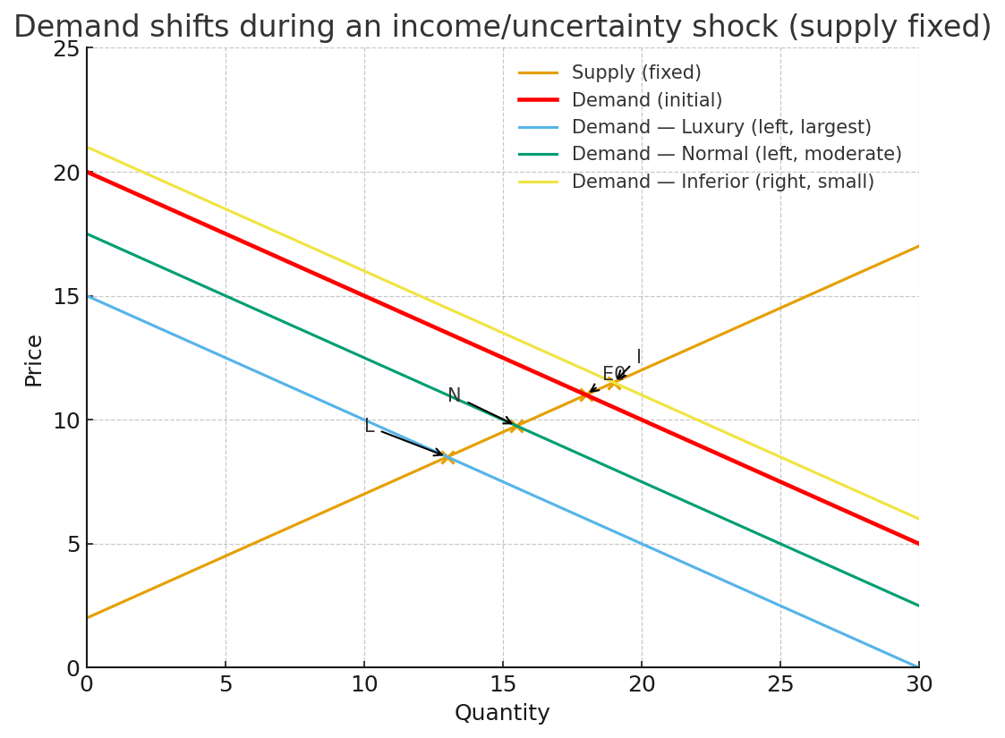
Note: In the figure above the points E0, I, N, and L correspond, to the pre-shock equilibrium (all goods), post-shock inferior goods equilibrium, post shock normal goods equilibrium, and post shock luxury goods equilibrium, respectively.

c) (11 pts – 3pts for each correct reasoning and supply shifts; 2 pts for correct new ranking)
- Most elastic Demand: High-end smartphones (luxury durable).
- Demand shock: big leftward shift
- Supply (≈ 1 month): roughly unchanged—production takes time and decisions are set in advance; inventory already built
- Net short-run price effect: largest price drop, quantity falls too (see figure below).
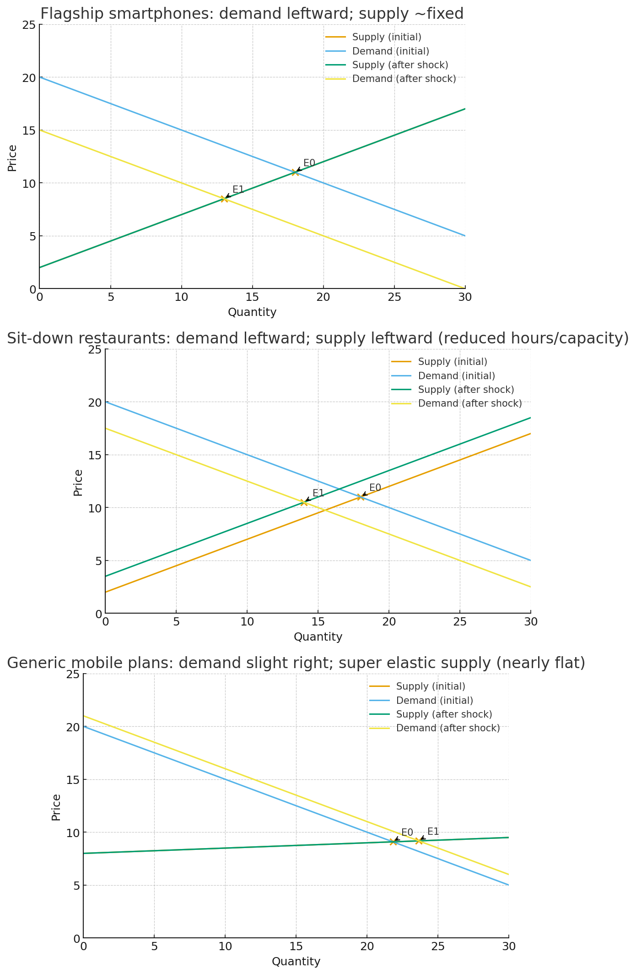
Note: In the figure above, the points E0 and E1 correspond to the pre-shock and the post-shock equilibrium, respectively.

- Mid-price-range restaurants (normal services).
- Demand shock: leftward shift (households trim dining out).
- Supply (≈ 1 month): leftward shift (restaurants cut hours, close some days, reduce freelance staff, buy less food) — capacity can be reduced quickly.
- Net short-run price effect: small price drop (demand falls but supply falls too), with a larger quantity drop than in case 1.


Note: In the figure above, the points E0 and E1 correspond to the pre-shock and the post-shock equilibrium, respectively.

- Store-brand groceries (essential good)
- Demand (shock): rightward shift (households trade-down toward cheaper staples)
- Supply (≈ 1 month): moderately elastic (inventories, work extra shifts). Thus, supply can expand somewhat in the short run, but still with limits due to production/input constraints.
- Net short-run price effect: small price increase (quantity rises; price up modestly because supply can expand but not infinitely).

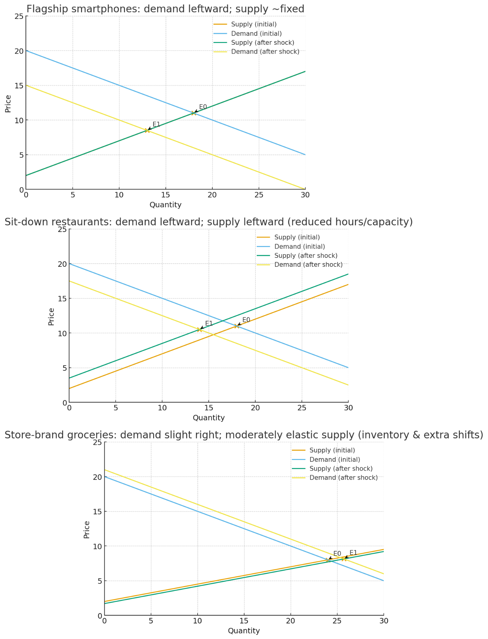

Note: In the figure above the points E0 and E1 correspond to the pre-shock and the post-shock equilibrium, respectively.

d) (2pts for explanation that mentions ambiguity, 1pt for each answer that is correct given previous assumptions)
In general, we cannot make a clear prediction for prices. Once both demand and supply can shift, the price change is ambiguous. It depends on the direction and size of each shift and on the elasticities of the curves

Problem 4: Consulting Project (25 points)
Starting point: Graph (8 pts). For simplicity, we use “Labor” to refer to low-skilled labor.
S₁
Wage

w₁
L₁
D₁

Labor

The equilibrium wage is where supply and demand for labor intersect, which is represented by the point (L₁, w₁).
Analysis: effect of unemployment benefits (12 pts)
Wage
S₂
S₁
w₂
w₁
Labor
D₁

L₁
L₂

If unemployment benefits increase significantly, the (low-skilled) labor supply curve shifts up (to the left). The reason is that the wage at which people are willing to work is now higher, because they have a more attractive “outside option” (i.e., receiving benefits while staying at home). This means that for any given wage, fewer individuals would be willing to work, in comparison to the original scenario. Another way to look at this is that an increase in unemployment benefits increases the opportunity cost of employment: compared to the original scenario, the decision to work implies giving up the additional benefits. Some individuals who were almost indifferent between working and not working, and leaned towards working, will now change their decision and stay at home.

Analysis of the demand side (5 points):
We do not have any indication that the labor demand curve will shift (at least not in the short run). Thus, you received full credit if you stated that labor demand remained unchanged. However, there are also other, more advanced possible answers. For example, in the long run, employers may increase automation, thereby reducing their labor demand, which would shift the labor demand curve down and reduce the equilibrium wage. Answers like this will also receive full credit.

